English

Home Learning Pack
Contents

SPaG
Spelling 1…………………………………………………………………………………………………………3
Spelling 2 ……………………………………………………………………………………………………… 4
Spelling 3 ……………………………………………………………………………………………………… 5
Spelling 4 ……………………………………………………………………………………………………… 6
Spelling 5 ……………………………………………………………………………………………………… 7
Capital Letters and Full Stops ………………………………………………………………… 8
Commas ………………………………………………………………………………………………………… 9
Adjectives ……………………………………………………………………………………………………10
Adverbs …………………………………………………………………………………………………………11
Semi-Colons..…………………………………………………………………………………………………12
Speech Marks ……………………………………………………………………………………………13

Reading Skills
Comprehension – The Woman in Black…………………………………………………… 14
Comprehension – Stephen King’s ‘On Writing’……………………………………… 18
Comprehension – ‘London’ by William Blake ………………………………………… 22

Writing Skills
Responding to a Picture…………………………………………………………………………… 25
Write a Newspaper ………………………………………………………………………………… 28

Extras Section
Wordsearch ……………………………………………………………………………………………… 30
Design a Book Cover ………………………………………………………………………………… 31
Design a Bookmark …………………………………………………………………………………… 32
Make Your Own Comic……………………………………………………………………………… 33

Spelling 1

In the following sentences, there are some spelling mistakes.

Write the sentence out with your corrections on the lines underneath.

- Parlament will be sending forren aid to countries that are desperet for help after the disastrous event.

……………………………………………………………………………………………………………

- I deccided to respond out of curriousity.

……………………………………………………………………………………………………………

- My mischeevius naybor is a newsance.

……………………………………………………………………………………………………………

- The lightnning was determinned to haras us all night.

……………………………………………………………………………………………………………

- The soljer was equiped for the training exercise.

……………………………………………………………………………………………………………

Spelling 2

In the following sentences, there are some spelling mistakes.
Write the sentence out with your corrections on the lines underneath.

- I reccognised the resterant from the proggrame.

……………………………………………………………………………………………………………

- We need a signnature from the secretery for enviroment.

……………………………………………………………………………………………………………

- “Stop using that thorughly awful langauge now!” the anshunt librarian hissed.

……………………………………………………………………………………………………………

- I pulled a mussle from carrying all of the equippment.

……………………………………………………………………………………………………………

……………………………………………………………………………………………………………

- My favourite rapper has just bought his twelvth yocht.

……………………………………………………………………………………………………………
Spelling 3

In the following sentences, there are some spelling mistakes.
Write the sentence out with your corrections on the lines underneath.

- Jack had to write out fourty lines from the dictionery.

……………………………………………………………………………………………………………

- Ella received a nasty bruse from the agresive tackle.

……………………………………………………………………………………………………………

- I will embaras myself in music lessons because I have no rythm.

……………………………………………………………………………………………………………

……………………………………………………………………………………………………………

- There was a varyity of veggtables.

……………………………………………………………………………………………………………

- We freqwently sucede in our football competishuns.

……………………………………………………………………………………………………………
Spelling 4

In the following sentences, there are some spelling mistakes.

Write the sentence out with your corrections on the lines underneath.

- We need to comunicate to stop prejuddice.

……………………………………………………………………………………………………………

- I recommend that you try not to interfeer.

……………………………………………………………………………………………………………

- The whole comunity attended the service at the cemetary.

……………………………………………………………………………………………………………

……………………………………………………………………………………………………………

- Acording to my sister, it was a marvellus bargin.

……………………………………………………………………………………………………………

- The comitee was shocked by the controvasy.

……………………………………………………………………………………………………………
Spelling 5

In the following sentences, there are some spelling mistakes.

Write the sentence out with your corrections on the lines underneath.

- There was a missterius simbol that was not fammiliar.

……………………………………………………………………………………………………………

- I had a stommac ake so the nurse checked my temperiture.

……………………………………………………………………………………………………………

- I apreciate a nice rhime in a poem.

……………………………………………………………………………………………………………

- My sinsere appologies.

……………………………………………………………………………………………………………

- I was conshus my conshunce wouldn’t allow it.

……………………………………………………………………………………………………………

Capital Letters and Full Stops

Read the paragraph and put a circle around where there should be a full stop or a capital letter.

i went to see my friend on saturday his dad cooked us some pasta and then we went outside to play football we excitedly grabbed our coats to go outside for the first time in ages it had been raining non-stop in manchester we got to the park and set our coats on the ground because there were no goals all of a sudden, the heavens opened and we were pelted with the hardest, coldest hailstones we’d ever seen we ran over to pick up our coats to put them back on, I bundled our ball under my arm and we ran back as fast as we could the disappointment hit us as soon as we walked in dripping wet and frozen to the bone, we miserably trudged back into the warm kitchen my friend’s dad took one look at us and laughed “anyone for a hot chocolate?” he asked us we soon felt better after that

Comma Practice

Commas are really important. They separate items in a list, separate extra information in a sentence and tell us when we need to stop for a pause.

Can you put in the missing commas in the list below?

- We packed sandwiches crisps and apples for lunch.

- I went to the shops with my friends Joe Anja and Malik.

- The cat had scratchy sharp claws.

- Spaghetti a long type of pasta is delicious with tomato sauce.

- I made sure I packed my phone charger socks and toothbrush this time!

- Effy gave up running for the train as she knew she wouldn’t make it on time.

- I woke up brushed my teeth and had a wash before school.

- Miguel Arteta who played for the club in his younger years has now taken on the role of manager.
Awesome Adjectives

Adjectives are words used to describe, e.g. beautiful, calm, spooky, hungry, noisy…etc.

Look at the pictures below and write three adjectives to describe each one. Use a thesaurus (you can find one online) if you get stuck or want to find extra ambitious adjectives!

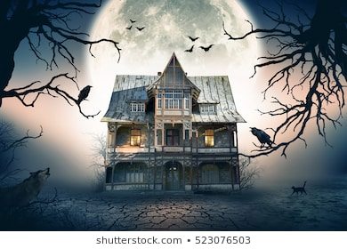
…………………………………………………………………………………………

…………………………………………………………………………………………

…………………………………………………………………………………………

…………………………………………………………………………………………

…………………………………………………………………………………………

…………………………………………………………………………………………

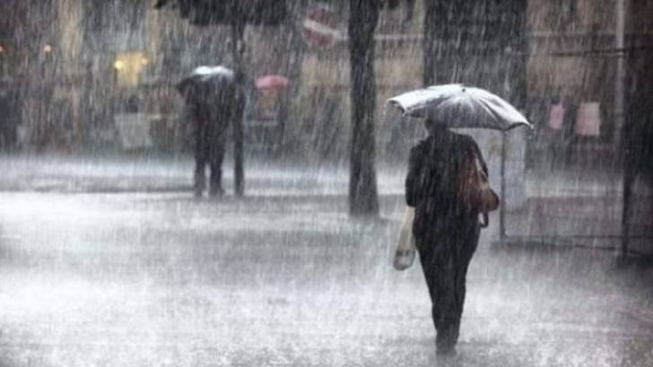
…………………………………………………………………………………………

…………………………………………………………………………………………

…………………………………………………………………………………………

…………………………………………………………………………………………

…………………………………………………………………………………………

…………………………………………………………………………………………

Adverbs

A verb is a doing (action) word. An adverb is a word put before or after the verb to tell you how that action is being done. They make our writing sound much more exciting.

For example: She kindly helped the old lady safely cross the road.

Write a sentence for each of the adverbs listed.

- Scarcely

………………………………………………………………………………………………………………………………………………….

- Searchingly

………………………………………………………………………………………………………………………………………………….

- Arrogantly

………………………………………………………………………………………………………………………………………………….

- Tremendously

………………………………………………………………………………………………………………………………………………….

- Recklessly

………………………………………………………………………………………………………………………………………………….

- Reluctantly

………………………………………………………………………………………………………………………………………………….

- Doubtfully

………………………………………………………………………………………………………………………………………………….

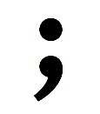
Semi-Colons

Adding a semi-colon can make your work seem more impressive. They can be used to list things or to take the place of a connective (this is what we’ll look at on this sheet now).

Task 1: Add semi-colon to where you think it should go.

- Give me a ring tomorrow I’ll let you know then.
- I’d recommend KFC for chips McDonald’s ones are always cold.
- You should try and cover Tom in the match he always gets goals in.
- I like orange juice Keiran prefers apple.
- The board had a new notice on it there would be an emergency meeting on Friday.
- Don’t use so much salt it is bad for you.

Task 2: Write three of your own sentences using semi-colons

- ………………………………………………………………………………………………………………………………………

………………………………………………………………………………………………………………………………………

- ………………………………………………………………………………………………………………………………………

………………………………………………………………………………………………………………………………………

- ………………………………………………………………………………………………………………………………………

………………………………………………………………………………………………………………………………………

Speech Marks

Speech marks are used to show when direct speech starts and ends. For example: The football fan shouted “Goal!” as loudly as he could.

Task 1: Add the speech marks to the following sentences.

- What time are you going there asked Sarah.
- The police officer shouted Freeze! when he saw the thief.
- Where are my glasses? demanded Tom.
- I don’t know, his friend shrugged. Have you checked the top of your head?
- What is important, the teacher said, Is not to rush your work.
Task 2: Write three examples of your own speech sentences.
- …………………………………………………………………………………………………………………………………….

…………………………………………………………………………………………………………………………………….

- …………………………………………………………………………………………………………………………………….

…………………………………………………………………………………………………………………………………….

- …………………………………………………………………………………………………………………………………….

…………………………………………………………………………………………………………………………………….
Comprehension – Fiction

Extract from The Woman in Black by Susan Hill (1983)

Then from somewhere, out of that howling darkness, a cry came to my ears, catapulting me back into the present and banishing all tranquillity.
I listened hard. Nothing. The tumult of the wind, like a banshee, and the banging and rattling of the window in its old, ill-fitting frame. Then yes, again, a cry, that familiar cry of desperation and anguish, a cry for help from a child somewhere out on the marsh.
There was no child. I knew that. How could there be? Yet how could I lie here and ignore even the crying of some long-dead ghost?
“Rest in peace,” I thought, but this poor one did not, could not.
After a few moments I got up. I would go down into the kitchen and make myself a drink, stir up the fire a little and sit beside it trying, trying to shut out that calling voice for which I could do nothing, and no one had been able to do anything for … how many years?
As I went out onto the landing, Spider the dog following me at once, two things happened together. I had the impression of someone who had just that very second before gone past me on their way from the top of the stairs to one of the other rooms, and, as a tremendous blast of wind hit the house so that it all but seemed to rock at the impact, the lights went out. I had not bothered to pick up my torch from the bedside table and now I stood in the pitch blackness, unsure for a moment of my bearings.
And the person who had gone by, and who was now in this house with me? I had seen no one, felt nothing. There had been no movement, no brush of a sleeve against mine, no disturbance of the air, I had not even heard a footstep. I had simply the absolutely certain sense of someone just having passed close to me and gone away down the corridor. Down the short narrow corridor that led to the nursery whose door had been so firmly locked and then, inexplicably, opened.
For a moment I actually began to conjecture that there was indeed someone — another human being — living here in this house, a person who hid themselves away in that mysterious nursery and came out at night to fetch food and drink and to take the air. Perhaps it was the woman in black? Had Mrs Drablow harboured some reclusive old sister or retainer, had she left behind her a mad friend that no one had known about? My brain span all manner of wild, incoherent fantasies as I tried desperately to provide a rational explanation for the presence I had been so aware of. But then they ceased. There was no living occupant of Eel Marsh House other than myself and Samuel Daily’s dog. Whatever was about, whoever I had seen, and heard rocking, and who had passed me by just now, whoever had opened the locked door was not “real”. No. But what was “real”? At that moment I began to doubt my own reality.
The first thing I must have was a light and I groped my way back across to my bed, reached over it and got my hand to the torch at last, took a step back, stumbled over the dog who was at my heels and dropped the torch. It went spinning away across the floor and fell somewhere by the window with a crash and the faint sound of breaking glass. I cursed but managed, by crawling about on my hands and knees, to find it again and to press the switch. No light came on. The torch had broken.
For a moment I was as near to weeping tears of despair and fear, frustration and tension, as I had ever been since my childhood. But instead of crying I drummed my fists upon the floorboards, in a burst of violent rage, until they throbbed.
It was Spider who brought me to my senses by scratching a little at my arm and then by licking the hand I stretched out to her. We sat on the floor together and I hugged her warm body to me, glad of her, thoroughly ashamed of myself, calmer and relieved, while the wind boomed and roared without, and again and again I heard that child’s terrible cry borne on the gusts towards me.

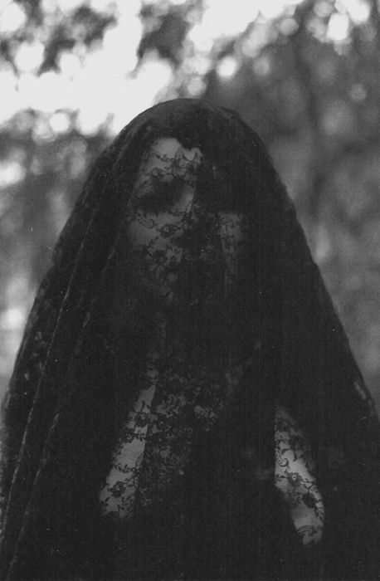

- How does Susan Hill create tension the opening of the extract?

…………………………………………………………………………………………………………………………………….

…………………………………………………………………………………………………………………………………….

…………………………………………………………………………………………………………………………………….

…………………………………………………………………………………………………………………………………….

- Find one example of a rhetorical question, write it down and explain the effect it has on the reader.

…………………………………………………………………………………………………………………………………….

…………………………………………………………………………………………………………………………………….

…………………………………………………………………………………………………………………………………….

- Why could the author have chosen the name ‘Drablow’?

…………………………………………………………………………………………………………………………………….

…………………………………………………………………………………………………………………………………….

…………………………………………………………………………………………………………………………………….

- Find two examples of personification and explain the effect they have.

…………………………………………………………………………………………………………………………………….

…………………………………………………………………………………………………………………………………….

…………………………………………………………………………………………………………………………………….

…………………………………………………………………………………………………………………………………….

- How does the author use sentence structure to heighten the suspense in the extract?

…………………………………………………………………………………………………………………………………….

…………………………………………………………………………………………………………………………………….

- Does the text have any features of gothic literature?

…………………………………………………………………………………………………………………………………….

…………………………………………………………………………………………………………………………………….

- The extract mentions a child and a nursery. Does this make the text more or less spooky? Explain your reasons why.

…………………………………………………………………………………………………………………………………….

…………………………………………………………………………………………………………………………………….

…………………………………………………………………………………………………………………………………….

…………………………………………………………………………………………………………………………………….

…………………………………………………………………………………………………………………………………….

- Find what emotions the narrator experiences and back your answer up with evidence from the text (quotes).

…………………………………………………………………………………………………………………………………….

…………………………………………………………………………………………………………………………………….

…………………………………………………………………………………………………………………………………….

…………………………………………………………………………………………………………………………………….

…………………………………………………………………………………………………………………………………….
Comprehension – Non-Fiction

Stephen King is a successful horror, suspense and fantasy writer, who has written books such as It, the Dark Tower trilogy, Carrie, The Shining and Pet Sematary.
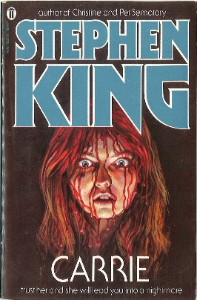
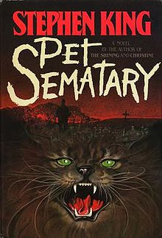
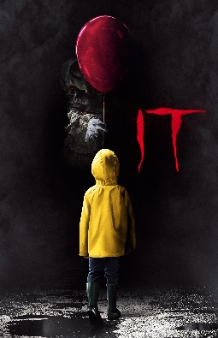
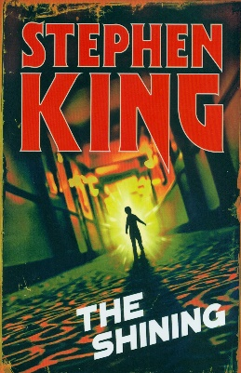

Read the extract and answer the questions at the end

Extract from Stephen King’s On Writing

If you want to be a writer, you must do two things above all others: read a lot and write a lot. There's no way around these two things that I'm aware of, no shortcut.
I'm a slow reader, but I usually get through seventy or eighty books a year, mostly fiction. I don't read in order to study the craft; I read because I like to read. It's what I do at night, kicked back in my blue chair. Similarly, I don't read fiction to study the art of fiction, but simply because I like stories. Yet there is a learning process going on. Every book you pick up has its own lesson or lessons, and quite often the bad books have more to teach than the good ones.
When I was in the eighth grade, I happened upon a paperback novel by Murray Leinster, a science fiction pulp writer who did most of his work during the forties and fifties, when magazines like Amazing Stories paid a penny a word. I had read other books by Mr. Leinster, enough to know that the quality of his writing was uneven. This particular tale, which was about mining in the asteroid belt, was one of his less successful efforts. Only that's too kind. It was terrible, actually, a story populated by paper-thin characters and driven by outlandish plot developments. Worst of all (or so it seemed to me at the time), Leinster had fallen in love with the word zestful.

Characters watched the approach of ore-bearing asteroids with zestful smiles. Characters sat down to supper aboard their mining ship with zestful anticipation. Near the end of the book, the hero swept the blonde heroine into a zestful embrace. For me, it was the literary equivalent of a smallpox vaccination: I have never, so far as I know, used the word zestful in a novel or a story. God willing, I never will.

Good writing, on the other hand, teaches the learning writer about style, graceful narration, plot development, the creation of believable characters, and truth-telling. A novel like The Grapes of Wrath may fill a new writer with feelings of despair and good old-fashioned jealousy -- "I'll never be able to write anything that good, not if I live to be a thousand" -- but such feelings can also serve as a spur, goading the writer to work harder and aim higher. Being swept away by a combination of great story and great writing -- of being flattened, in fact -- is part of every writer's necessary formation. You cannot hope to sweep someone else away by the force of your writing until it has been done to you.

- What two things does King say you have to do to be a good writer?

…………………………………………………………………………………………………………………………………….

…………………………………………………………………………………………………………………………………….

- What is the author’s opinion on bad books?

…………………………………………………………………………………………………………………………………….

…………………………………………………………………………………………………………………………………….

…………………………………………………………………………………………………………………………………….

- Why has the author never used the word ‘zestful’ in his writing?

…………………………………………………………………………………………………………………………………….

…………………………………………………………………………………………………………………………………….

…………………………………………………………………………………………………………………………………….

- What are the five ingredients for a good story?

…………………………………………………………………………………………………………………………………….

…………………………………………………………………………………………………………………………………….

…………………………………………………………………………………………………………………………………….

…………………………………………………………………………………………………………………………………….

…………………………………………………………………………………………………………………………………….

- What does the author say about feeling jealous?

…………………………………………………………………………………………………………………………………….

…………………………………………………………………………………………………………………………………….

- Find an example of a metaphor and explain it.

…………………………………………………………………………………………………………………………………….

…………………………………………………………………………………………………………………………………….

…………………………………………………………………………………………………………………………………….

…………………………………………………………………………………………………………………………………….

- What does the author say is important if you want to be a good writer? Make sure to include evidence in your answer.

…………………………………………………………………………………………………………………………………….

…………………………………………………………………………………………………………………………………….

…………………………………………………………………………………………………………………………………….

…………………………………………………………………………………………………………………………………….

…………………………………………………………………………………………………………………………………….

…………………………………………………………………………………………………………………………………….

- If you could, what question would you like to ask Stephen King?

…………………………………………………………………………………………………………………………………….

…………………………………………………………………………………………………………………………………….

Comprehension – Poetry

Read the poem and answer the questions at the end

London

By William Blake

I wander thro' each charter'd street,
Near where the charter'd Thames does flow.
And mark in every face I meet
Marks of weakness, marks of woe.

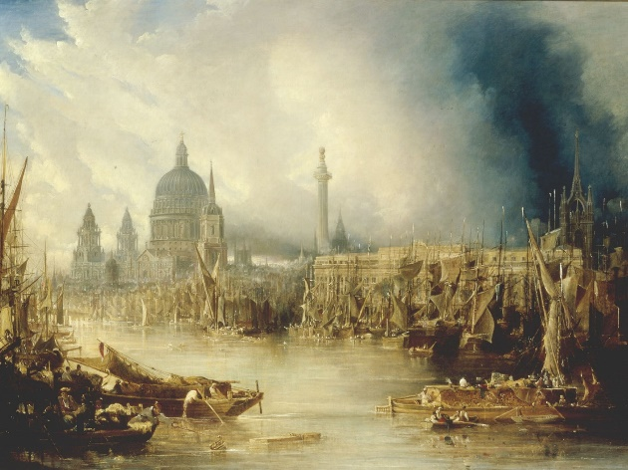
In every cry of every Man,
In every Infants cry of fear,
In every voice: in every ban,
The mind-forg'd manacles I hear

How the Chimney-sweepers cry
Every blackning Church appalls,
And the hapless Soldiers sigh
Runs in blood down Palace walls

But most thro' midnight streets I hear
How the youthful Harlots curse
Blasts the new-born Infants tear
And blights with plagues the Marriage hearse

Glossary

Mind-forg’d: made in our minds Manacles: chains and cuffs to restrain someone
Blights: spoils or damages Charter’d: can either mean ‘controlled’ or ‘mapped’

- In the first stanza (verse), what impression do we get of the people who live in London?

…………………………………………………………………………………………………………………………………….

…………………………………………………………………………………………………………………………………….

- What meanings could the word ‘marks’ have?

…………………………………………………………………………………………………………………………………….

…………………………………………………………………………………………………………………………………….

…………………………………………………………………………………………………………………………………….

- Hearses are used in funerals. Why has Blake used a hearse to describe marriage?

…………………………………………………………………………………………………………………………………….

…………………………………………………………………………………………………………………………………….

- Can you find an example of personification (when something not human is given human qualities)?

…………………………………………………………………………………………………………………………………….

…………………………………………………………………………………………………………………………………….

- Is there an image that you find particularly powerful in the poem? Give a reason why.

…………………………………………………………………………………………………………………………………….

…………………………………………………………………………………………………………………………………….

- What do you think Blake means when he writes that the soldier’s sigh ‘runs in blood down palace walls’?

…………………………………………………………………………………………………………………………………….

…………………………………………………………………………………………………………………………………….

- Would you like to live in this London? Why/why not?

…………………………………………………………………………………………………………………………………….

…………………………………………………………………………………………………………………………………….

- What does Blake mean when he writes ‘mind-forg’d manacles’? See the glossary for help!

…………………………………………………………………………………………………………………………………….

…………………………………………………………………………………………………………………………………….

…………………………………………………………………………………………………………………………………….

…………………………………………………………………………………………………………………………………….

……………………………………………………………………………………………………………………………………

- Would you like to live in this London? Why/why not?

…………………………………………………………………………………………………………………………………….

…………………………………………………………………………………………………………………………………….

- If you could ask Blake one question, what would it be?

…………………………………………………………………………………………………………………………………….

…………………………………………………………………………………………………………………………………….

Creative Response to a Picture

Task: Imagine you are in this picture.

Make sure to:
- Describe what you can see, touch, taste, hear, smell
- Use as many language features as possible (similes, metaphors, personification, etc.)

………………………………………………………………………………………………………………………………………………….

………………………………………………………………………………………………………………………………………………….

………………………………………………………………………………………………………………………………………………….

………………………………………………………………………………………………………………………………………………….

………………………………………………………………………………………………………………………………………………….

………………………………………………………………………………………………………………………………………………….

………………………………………………………………………………………………………………………………………………….

………………………………………………………………………………………………………………………………………………….

………………………………………………………………………………………………………………………………………………….

………………………………………………………………………………………………………………………………………………….

………………………………………………………………………………………………………………………………………………….

………………………………………………………………………………………………………………………………………………….

………………………………………………………………………………………………………………………………………………….

………………………………………………………………………………………………………………………………………………….

………………………………………………………………………………………………………………………………………………….

………………………………………………………………………………………………………………………………………………….

………………………………………………………………………………………………………………………………………………….

………………………………………………………………………………………………………………………………………………….

………………………………………………………………………………………………………………………………………………….

………………………………………………………………………………………………………………………………………………….

………………………………………………………………………………………………………………………………………………….

………………………………………………………………………………………………………………………………………………….

………………………………………………………………………………………………………………………………………………….

………………………………………………………………………………………………………………………………………………….

………………………………………………………………………………………………………………………………………………….

………………………………………………………………………………………………………………………………………………….

………………………………………………………………………………………………………………………………………………….

………………………………………………………………………………………………………………………………………………….

………………………………………………………………………………………………………………………………………………….

………………………………………………………………………………………………………………………………………………….

………………………………………………………………………………………………………………………………………………….

………………………………………………………………………………………………………………………………………………….

………………………………………………………………………………………………………………………………………………….

………………………………………………………………………………………………………………………………………………….

………………………………………………………………………………………………………………………………………………….

………………………………………………………………………………………………………………………………………………….

………………………………………………………………………………………………………………………………………………….

………………………………………………………………………………………………………………………………………………….

………………………………………………………………………………………………………………………………………………….

………………………………………………………………………………………………………………………………………………….

………………………………………………………………………………………………………………………………………………….

………………………………………………………………………………………………………………………………………………….

………………………………………………………………………………………………………………………………………………….

………………………………………………………………………………………………………………………………………………….

Create a Newspaper

Task: Write a newspaper report based on this picture.
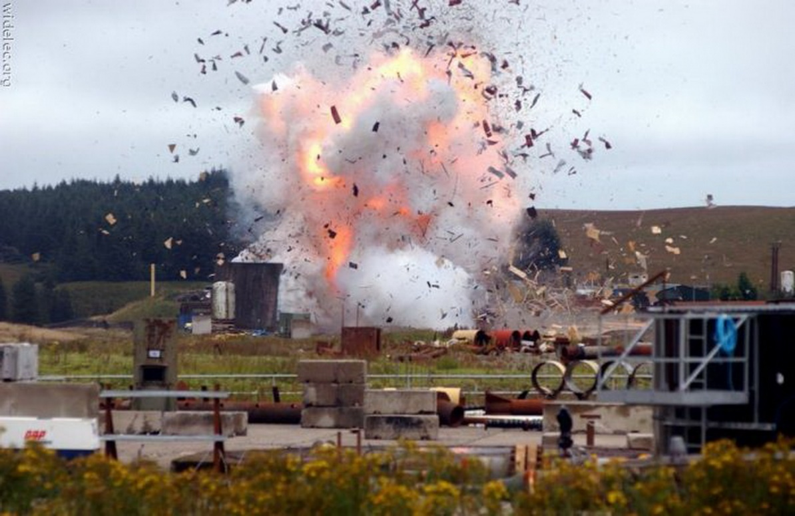

Make sure to include:

- A catchy headline
- The 5 Ws (what happened, where it happened, when it happened, who was there, why it happened)
- A quote from a witness who was there or a person discovering it when they came to work
- The nice-to-knows (what happened next, what is being done, what advice police are giving)
The Daily News

Price Date:

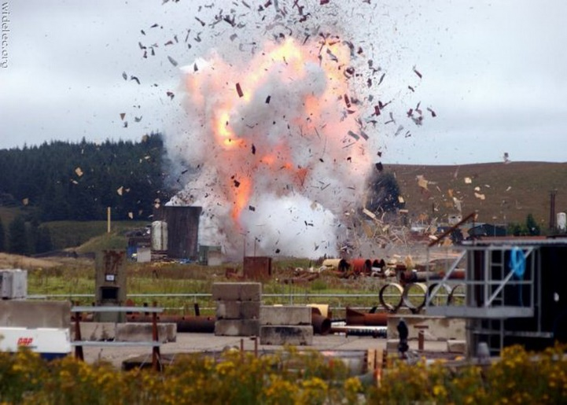

……………………………………………….

……………………………………………….

……………………………………………….

……………………………………………….

……………………………………………….

……………………………………………….

……………………………………………….

……………………………………………….

……………………………………………….

……………………………………………….

……………………………………………….

……………………………………………….

……………………………………………….

……………………………………………….

……………………………………………….

……………………………………………….

……………………………………………….

……………………………………………….

……………………………………………….

……………………………………………….

……………………………………………….

……………………………………………….

……………………………………………….

……………………………………………….

……………………………………………….

……………………………………………….

……………………………………………….

……………………………………………….

……………………………………………….

……………………………………………….

……………………………………………….

……………………………………………….

English Wordsearch
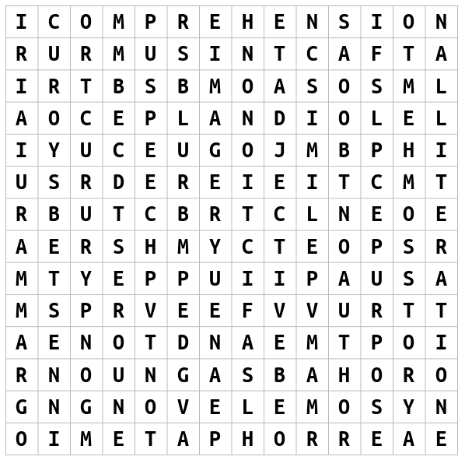
WORDS: Imagery Speech
Suspense Comprehension Metaphor
Grammar Alliteration Author
Story Simile Blurb
Adjective Tone Fact
Fiction Adverb Purpose
Novel Noun Poem

Design a Book Cover

Make sure to include the author name, title and make it bright and colourful! It can be an alternative cover for an existing book or better yet, make your own one up!

Design a Bookmark
Make sure it is bright and colourful. You could base it on your favourite book or superhero!

Create Your Own Comic

